SAVEETHA SCHOOL OF ENGINEERING
SAVEETHA INSTITUTE OF MEDICAL AND TECHNICAL SCIENCES
INSTITUTE OF CSE
CSA1514- CLOUD COMPUTING AND BIG DATA ANALYTICS
LIST OF EXPERIMENTS

NAME : B.V.THARUN REG NO: 192525155
COURSE NAME: Cloud Computing and Big Data Analytics
COURSE CODE: CSA1514

EXPERIMENT NO : 1
1. Flight Reservation System
Aim : To create and deploy a simple Flight Reservation System using a Cloud Service Provider to demonstrate the Software as a Service (SaaS) model, including flight search and reservation details.
Procedure
- Select a suitable Cloud Service Provider such as Zoho Creator, Google Cloud, AWS, or Microsoft Azure.
- Create an account and log in to the selected cloud platform.
- Create a new cloud application named Flight Reservation System.
- Design a reservation form with the following fields:
  - Trip Type – One Way / Round Trip
  - From
  - To
  - Departure Date
  - Return Date
  - Travelers
  - Class – Economy / Business / First Class
  - Fare Type
  - Flight Type – Domestic / International
- Add input fields and selection options to the application.
- Create a search/reservation button to submit the passenger details.
- Configure the application to store reservation details in the cloud database.
- Test the application by entering sample flight details.
- Access the application through a web browser without installing the application locally.
- Verify that the reservation data is stored and retrieved from the cloud.

Result
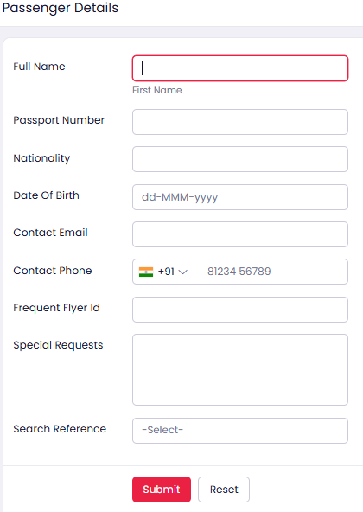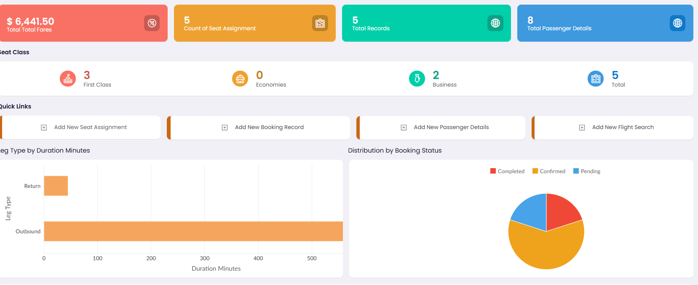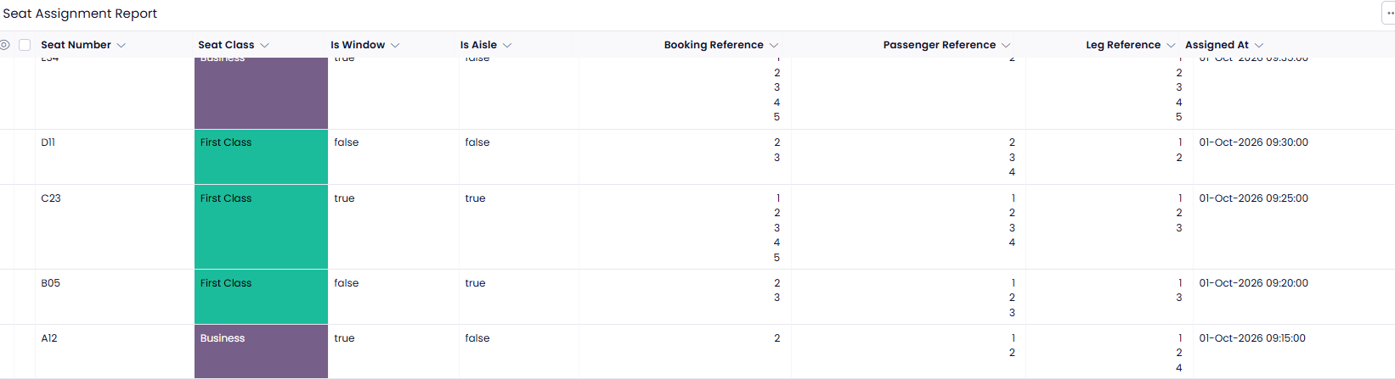

EXPERIMENT NO : 2
2. Property Buying & Rental System
Aim: To create a simple cloud-based Property Buying and Rental System for Chennai city using a Cloud Service Provider to demonstrate the Software as a Service (SaaS) model.
Procedure:
- Select a suitable Cloud Service Provider such as Zoho Creator, Google Cloud, AWS, or Microsoft Azure.
- Log in to the selected cloud platform.
- Create a new application named Chennai Property Buying & Rental System.
- Create a property search form with the following fields:
  - Transaction Type – Buy / Rent
  - Property Type – Residential / Commercial
  - Rental Agreement
  - Area
  - Place
  - Location
  - Budget / Range
  - Property Value
  - Number of Bedrooms
  - Contact Details
- Add Chennai locations such as Anna Nagar, T. Nagar, Adyar, Velachery, Tambaram, Porur, etc.
- Create separate options for Buy and Rent.
- Allow users to enter their preferred property area and price range.
- Store property details in the cloud database.
- Provide a search option to display properties matching the user's requirements.
- Test the application by entering sample property information.
- Access the application through the Internet using a web browser.
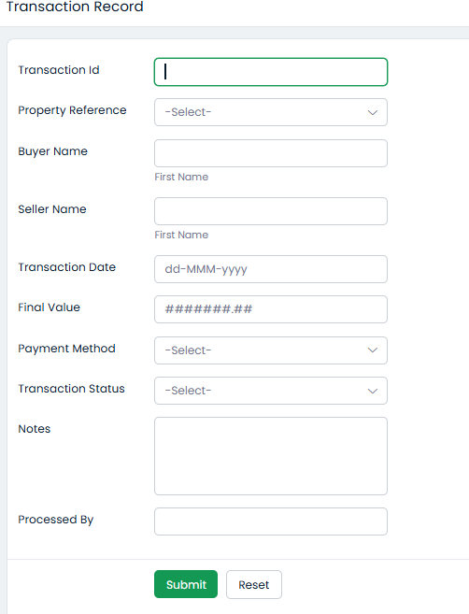
Result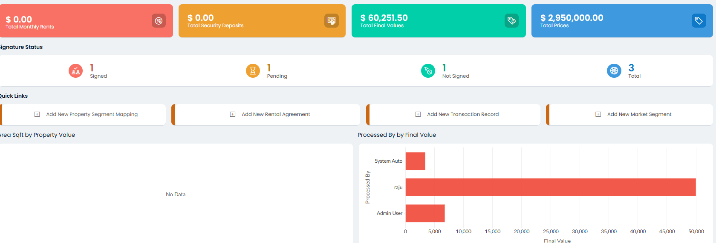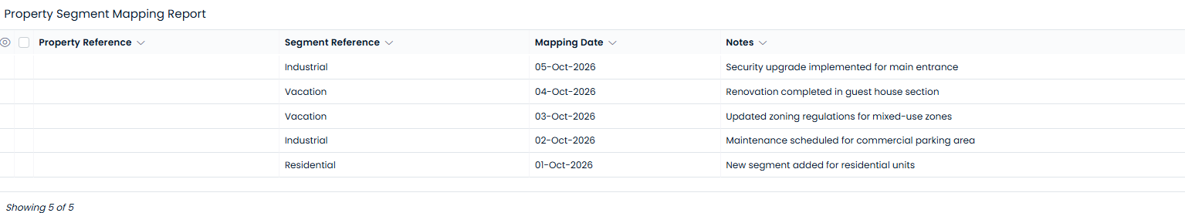

EXPERIMENT NO: 3
Car Booking Reservation System
Aim : To create a cloud-based Car Booking Reservation System using SaaS for searching and reserving cabs for local, rental, and out-station travel.
Procedure
- Create a cloud project using a suitable cloud service provider.
- Design the car booking webpage.
- Add fields such as:
  - Search for Cabs
  - From
  - To
  - Rental
  - Out Station
  - Package Type
  - Hours / Days
- Create a database for storing cab and customer information.
- Allow users to enter pickup and destination locations.
- Provide different booking types such as rental and out-station.
- Display suitable cab/package options.
- Allow the user to select and confirm a cab.
- Store the booking information in the cloud.
- Deploy and test the application.

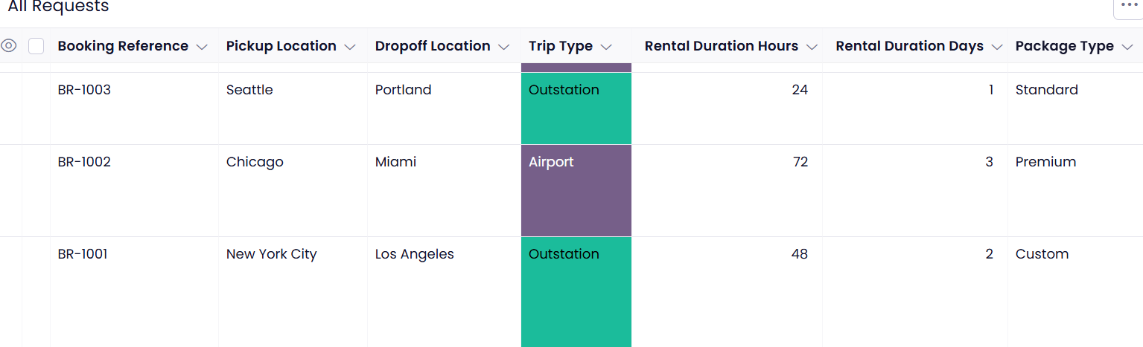
RESULT : 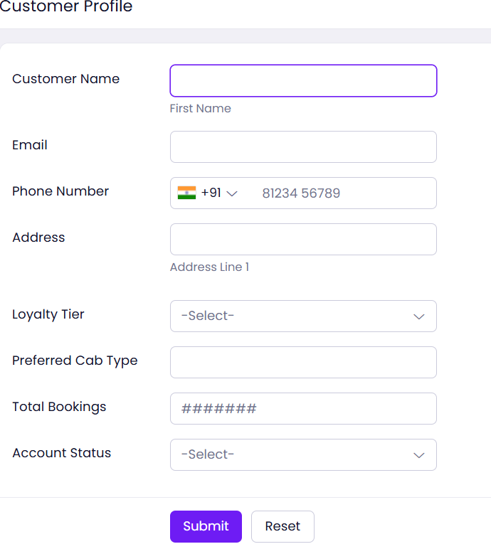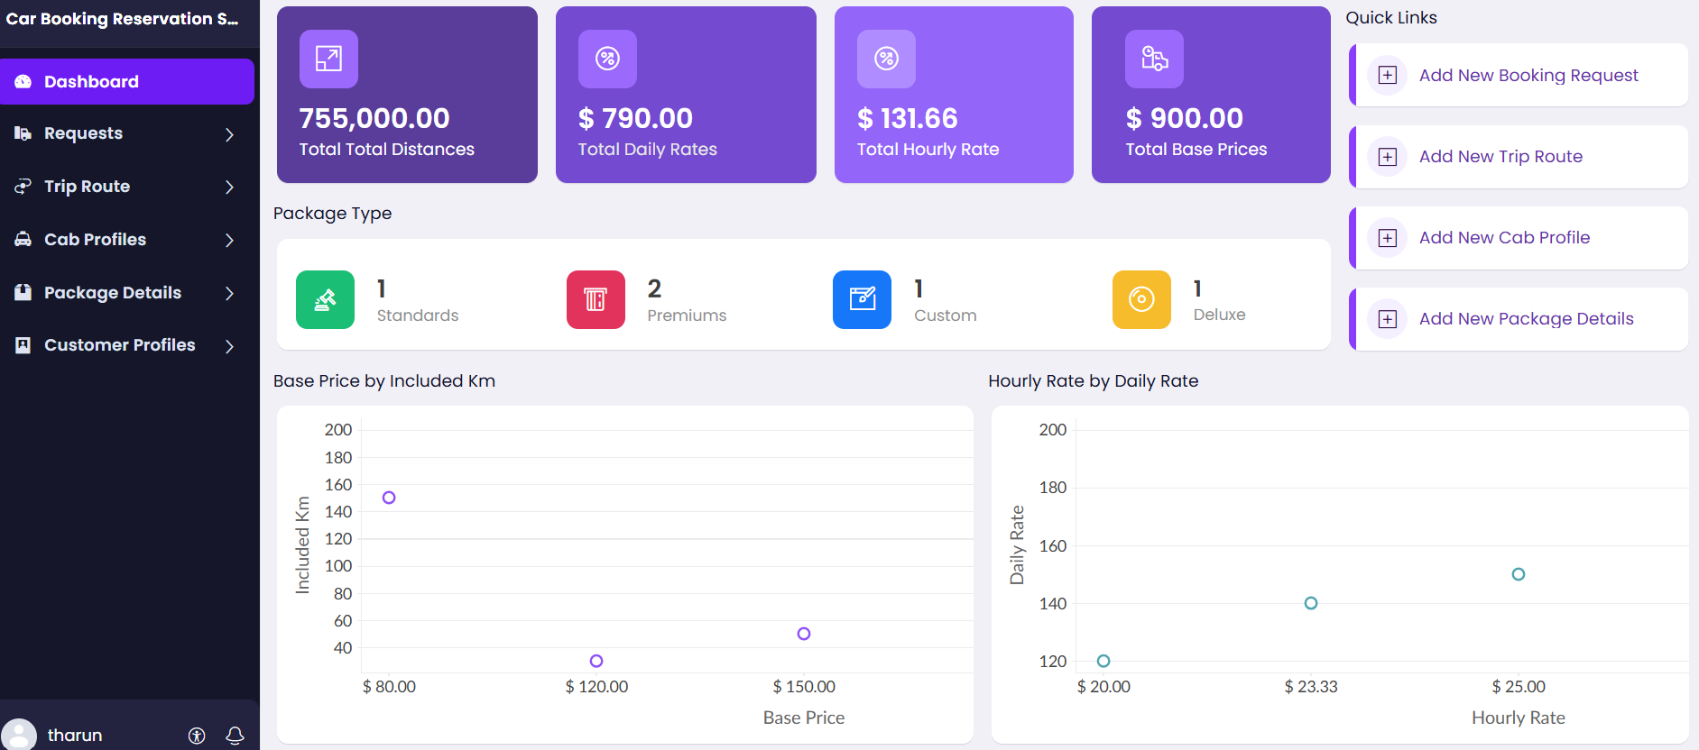
EXPERIMENT NO : 4
Library Book Reservation System
Aim : To develop a cloud-based Library Book Reservation System for the SIMATS Library using the SaaS model.
Procedure
- Create a cloud project and configure the required services.
- Design a library management webpage.
- Create fields for:
  - Title of Book
  - Author
  - Publication
  - Year
  - Edition
  - Number of Copies
  - Rack Number
  - Status
- Store book information in a cloud database.
- Provide a search facility for books.
- Display the availability status of each book.
- Allow students to reserve available books.
- Update the book status as Taken or Returned.
- Store reservation and return information.
- Deploy and test the application.

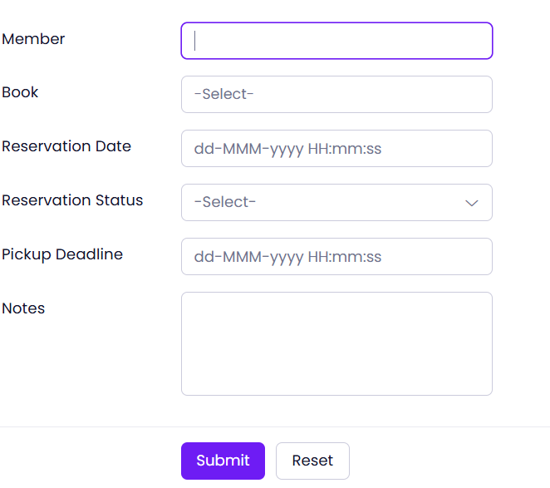
RESULT :

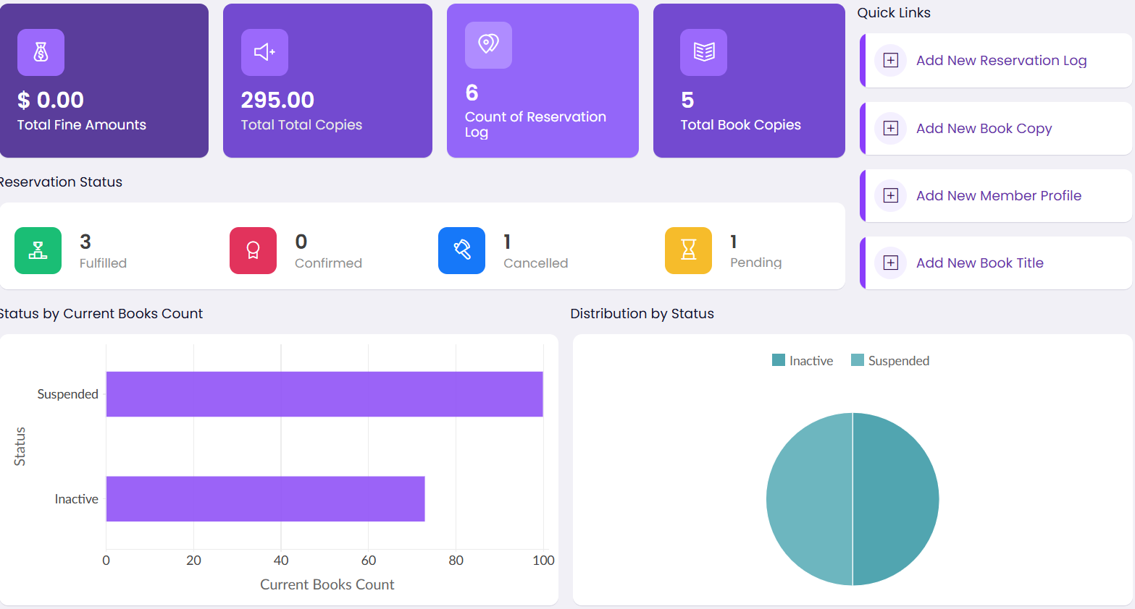

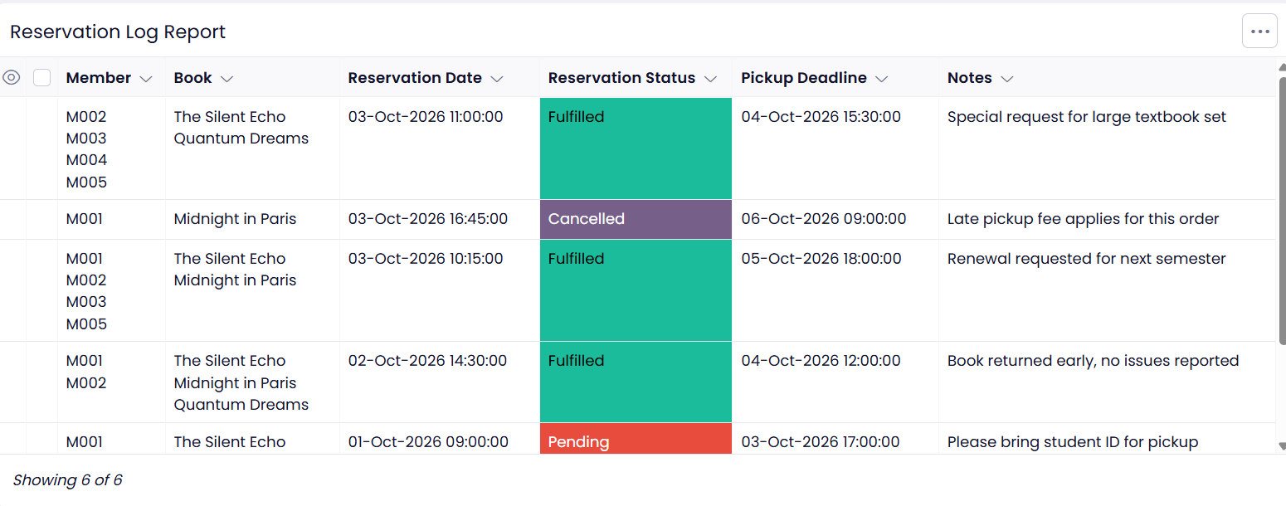

EXPERIMENT NO : 5
Mark Sheet Processing System
Aim : To create a cloud-based Mark Sheet Processing System using SaaS to calculate and display students' marks, average, percentage, rank, and overall performance.
Procedure
- Create a cloud application using a suitable cloud service provider.
- Design the student mark entry form.
- Add fields such as:
  - Student Name
  - Register Number
  - Subjects
  - Marks
  - Average
  - Percentage
  - Rank
  - Overall Performance
- Store student and marks information in a cloud database.
- Enter marks for each subject.
- Calculate the total marks and average.
- Calculate the percentage automatically.
- Determine the student's rank based on percentage.
- Display the overall performance of the student.
- Deploy and test the application through the cloud.

RESULT :
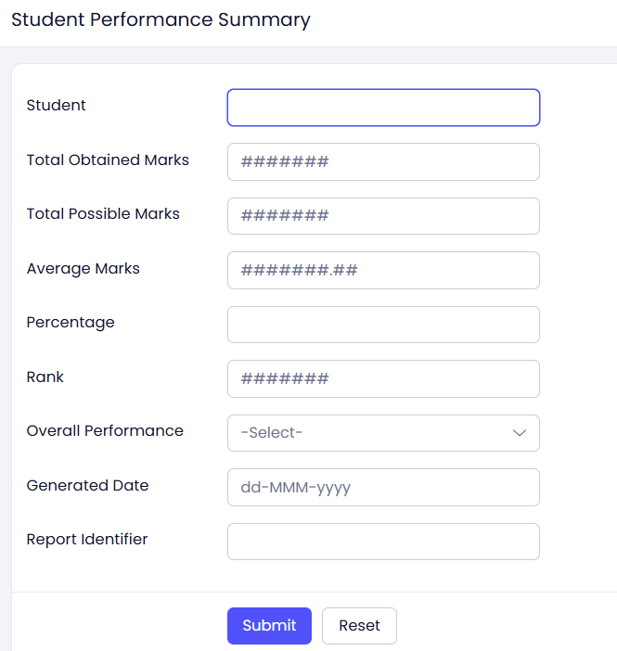
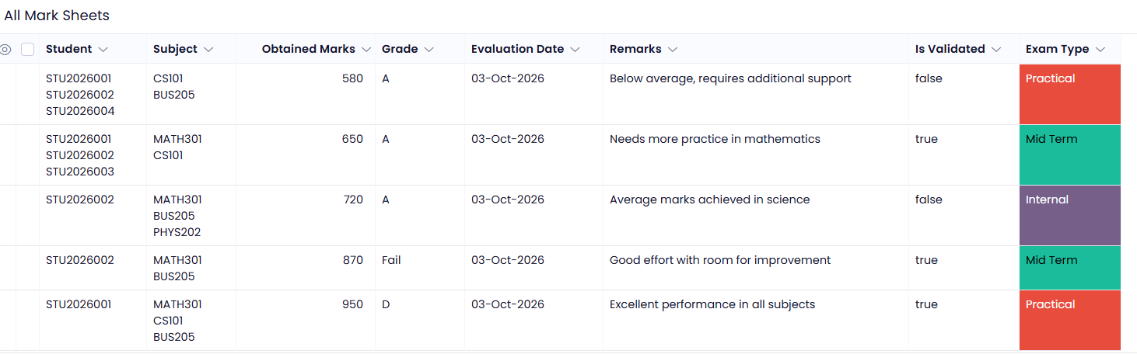
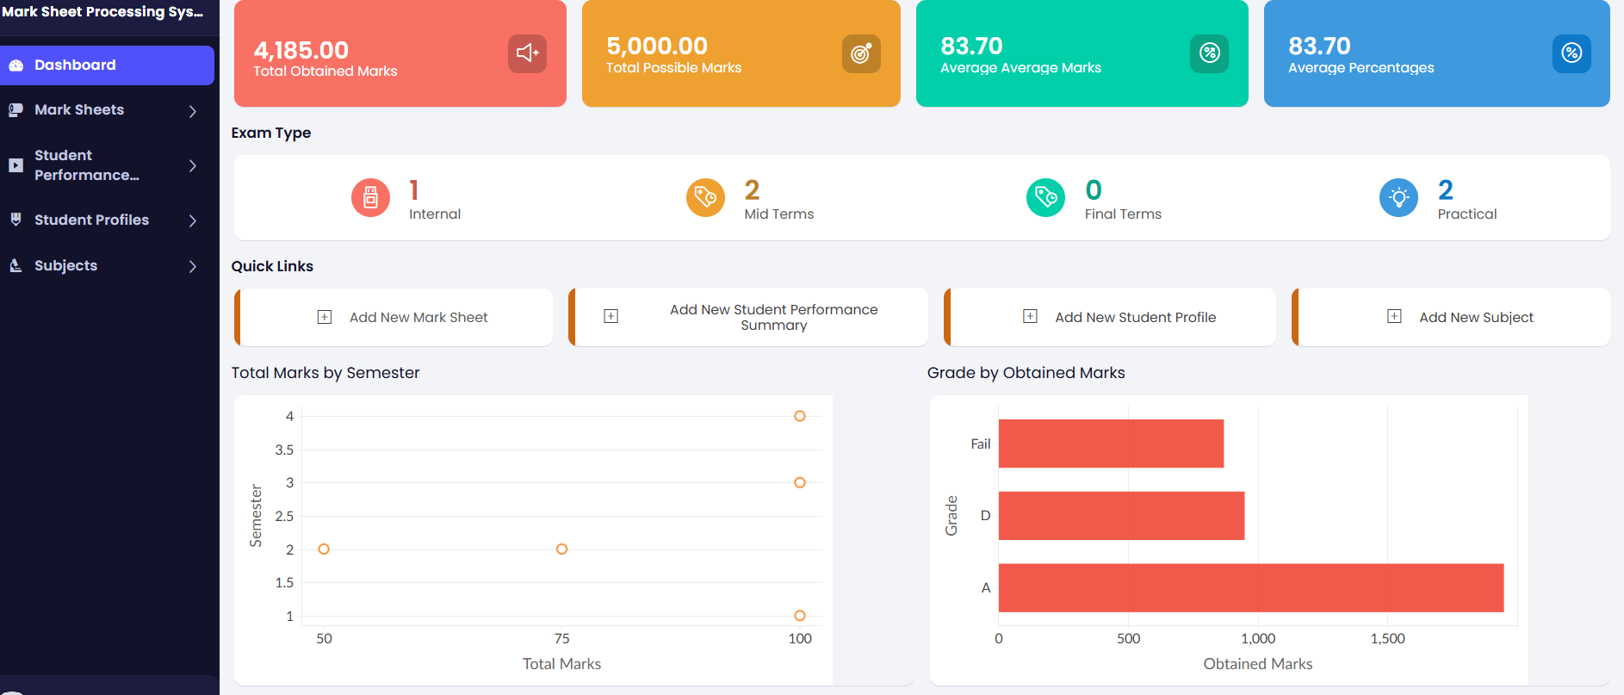
EXPERIMENT NO : 6
6. Payroll Processing System
Aim
To develop a cloud-based Payroll Processing System using SaaS for calculating employee salary, deductions, gross pay, and net pay.
Procedure
- Create a cloud project using a suitable cloud service provider.
- Design an employee payroll form.
- Include fields such as:
  - Employee Name
  - Experience in Present Organization
  - Overall Experience
  - Basic Pay
  - HRA
  - DA
  - TA
  - Gross Pay
  - Net Pay
- Store employee details in the cloud database.
- Enter the employee salary details.
- Calculate allowances such as HRA, DA, and TA.
- Calculate the gross salary.
- Calculate deductions and determine the net salary.
- Display the employee's salary details.
- Deploy and test the payroll application.

Result :
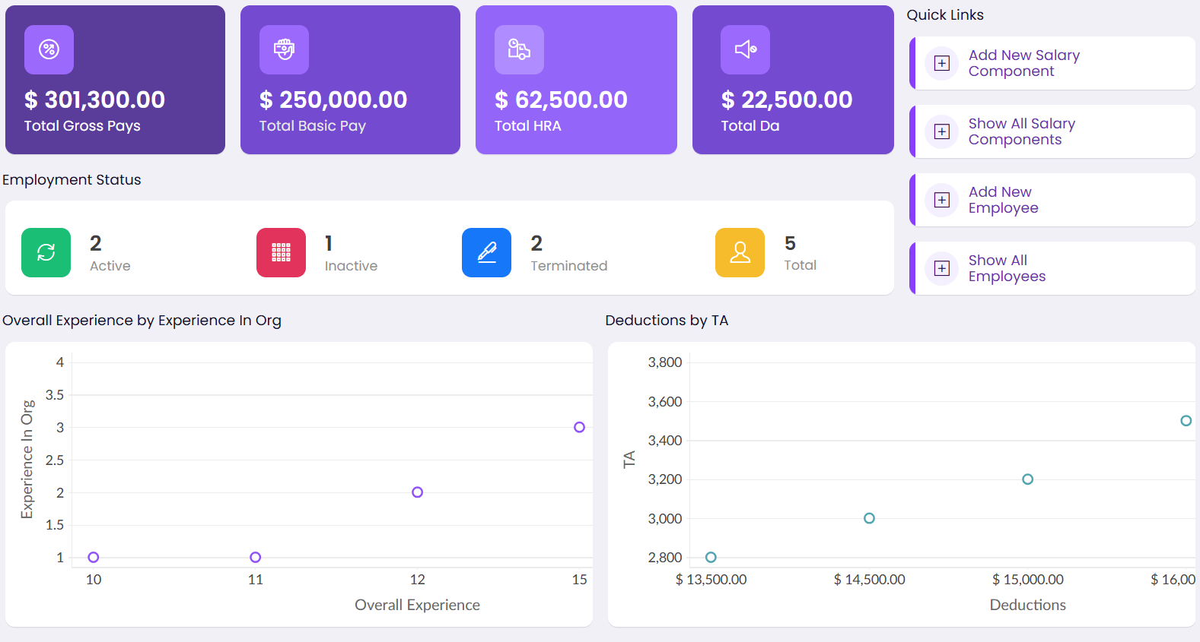
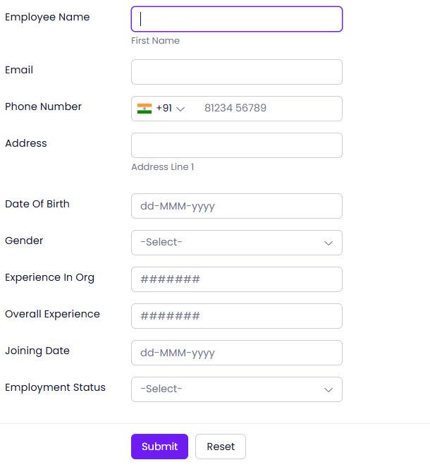

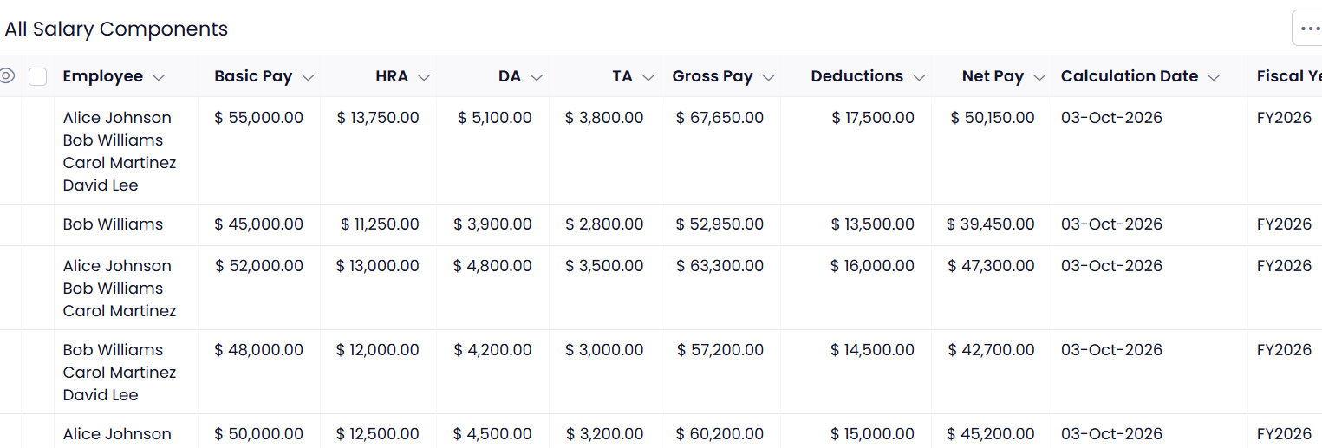
EXPERIMENT NO : 7
7. Student Attendance System
Aim : To create a cloud-based Student Attendance System using SaaS to record, calculate, and monitor student attendance.
Procedure
- Create a cloud project using a suitable cloud service provider.
- Design the student attendance interface.
- Include fields such as:
  - Student Name
  - Course
  - Present
  - Absent
  - Course Attendance
  - OD Request
  - Grade
  - Attendance Percentage
- Store student attendance information in the cloud database.
- Mark students as Present or Absent.
- Record approved OD requests.
- Calculate attendance percentage automatically.
- Assign attendance grades based on the percentage.
- Display the attendance report.
- Deploy and test the application.

Result

r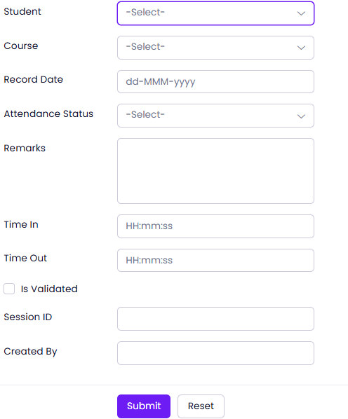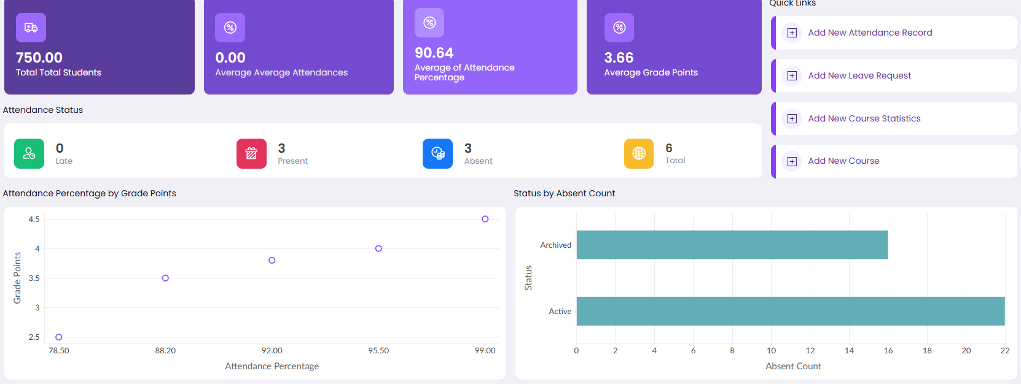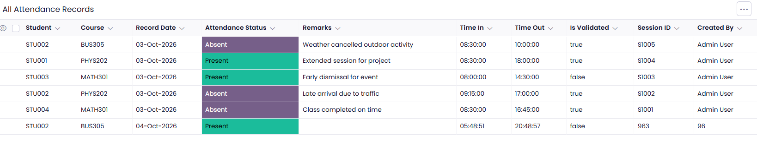

EXPERIMENT NO : 8

8. Student Counselling System
Aim To develop a cloud-based Student Counselling System using SaaS for maintaining student academic and personal information and assisting in counselling activities.
Procedure
- Create a cloud project using a suitable cloud service provider.
- Design the student counselling form.
- Add fields such as:
  - Student Name
  - Age
  - Address
  - Phone
  - Subjects Studied
  - Year of Passing
  - Percentage of Marks
  - Domain Interest
- Store the student details in a cloud database.
- Provide a form for entering academic information.
- Record the student's domain and career interests.
- Allow counsellors to view and update student information.
- Display the student's academic profile.
- Store counselling-related information securely.
- Deploy and test the application.

Result :

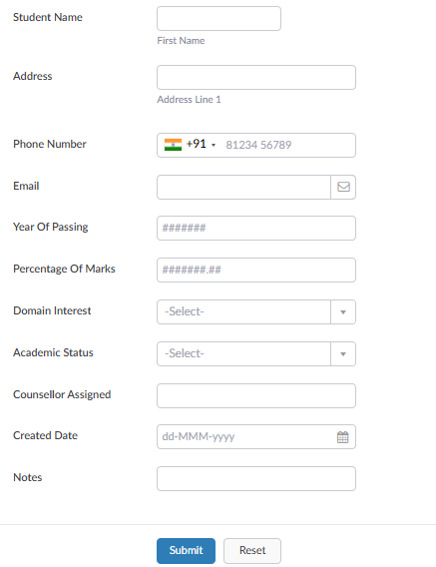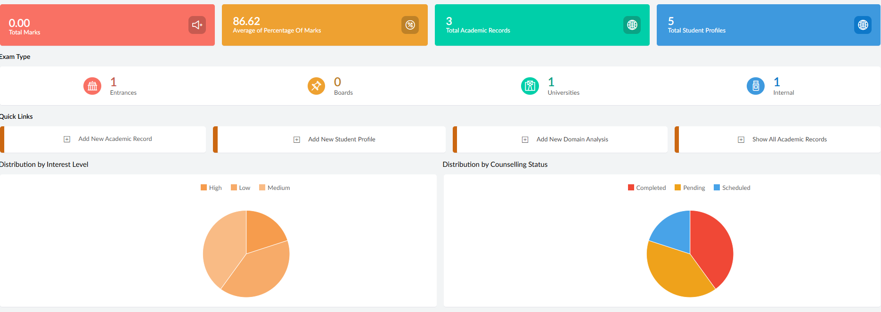
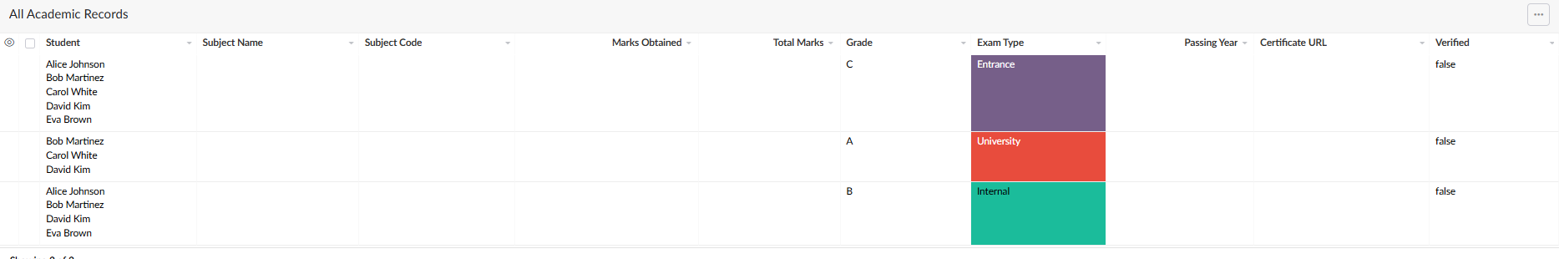

EXPERIMENT NO : 9
9. Hospital Information System – SIMATS Hospital
Aim To create a simple cloud-based Hospital Information System using a cloud service provider to demonstrate Software as a Service (SaaS).
Procedure
- Create an account in a cloud service provider such as Google Cloud, AWS, or Microsoft Azure.
- Create a new cloud project/application.
- Create a simple web application using HTML, CSS and JavaScript.
- Design a Patient Registration Form containing the required fields.
- Create a database to store patient information.
- Connect the web application to the database.
- Add functions to:
  - Register a new patient.
  - View patient details.
  - Search patient records.
  - Update patient information.
  - Delete patient records.
- Create a Doctor/Appointment Form for entering doctor name, department and appointment details.
- Deploy the application to the selected cloud platform.
- Access the application using the cloud-generated URL.
- Enter sample patient information and verify that the data is stored and displayed correctly.
12.Thus, the Hospital Information System is provided as a SaaS application, which can be accessed through a web browser without installing the application locally.
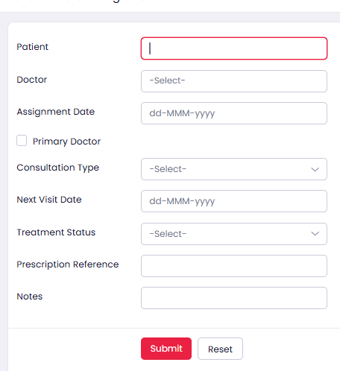
Result

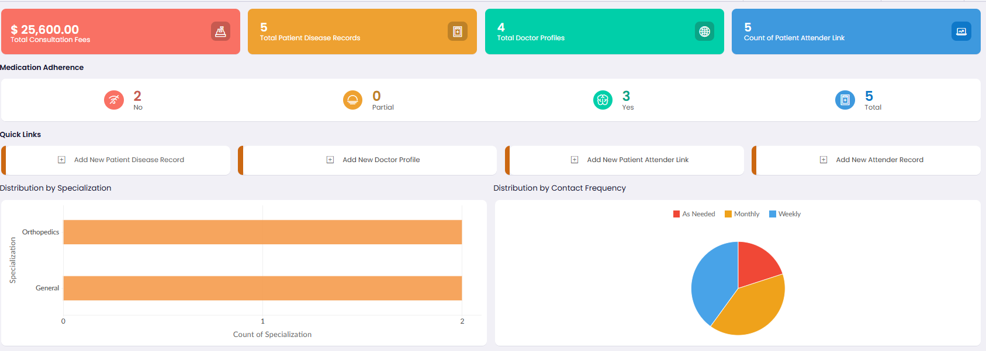
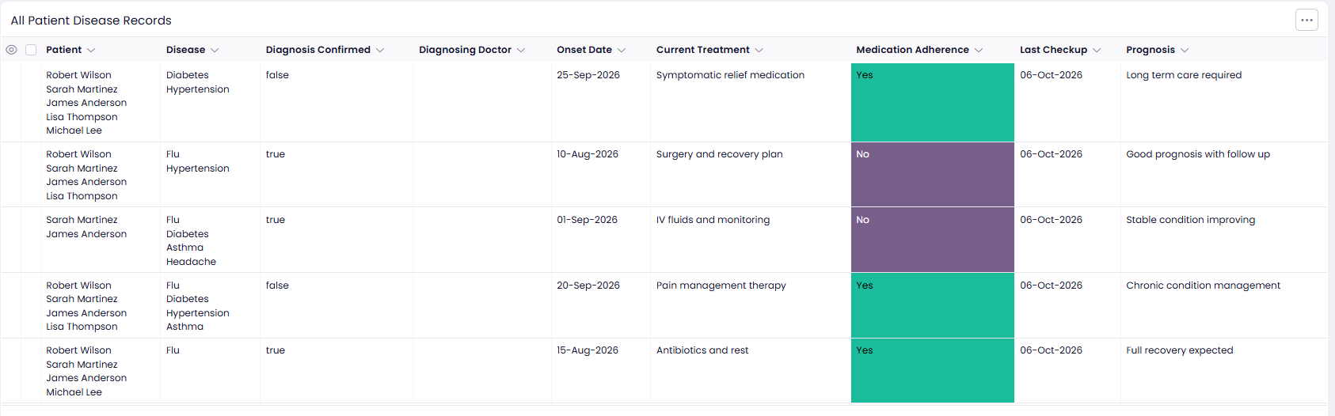

EXPERIMENT NO : 10
10. Student Information System
Aim: To develop a cloud-based Student Information System using SaaS for maintaining student academic information and generating attendance, progress and semester mark reports.
Procedure
- Create a cloud project using a suitable cloud service provider.
- Design the student information form.
- Add fields such as:
  - Student Name
  - Register Number
  - Address
  - Phone
  - Age
  - Courses
  - Grades
- Store the student details in a cloud database.
- Provide a form for entering attendance information.
- Record the student's academic progress and semester marks.
- Allow users to view and update student information.
- Display the student's attendance and progress report.
- Generate and display the semester mark sheet.
- Deploy and test the application as a SaaS-based Student Information System.

RESULT:
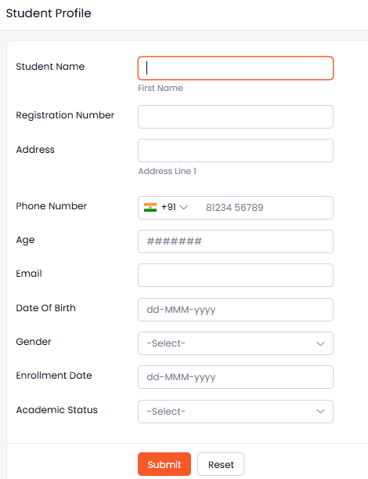

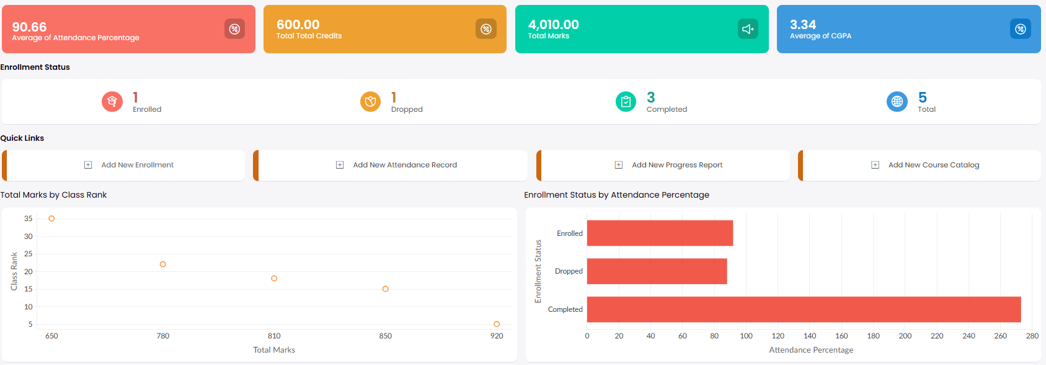

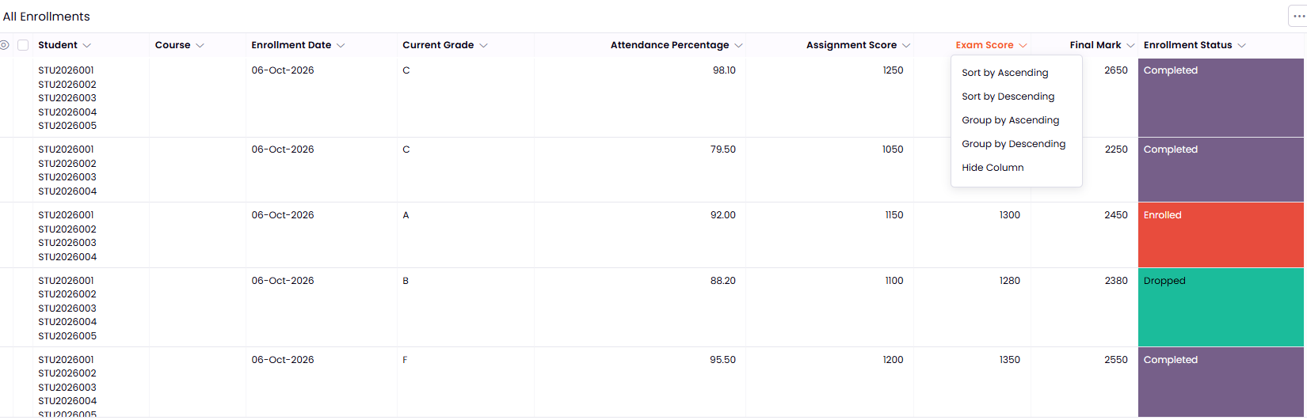

EXPERIMENT NO : 11
11. Online Supermarket System
Aim : To develop a cloud-based Online Supermarket System using SaaS for maintaining customer and product information and managing online shopping activities.
Procedure
- Create a cloud project using a suitable cloud service provider.
- Design the online supermarket form.
- Add fields such as:
  - Customer Name
  - Address
  - Phone
  - Email
  - Item Name
  - Quantity
  - Price
- Create an item classification form for categories such as groceries, fruits, vegetables and beverages.
- Store the customer and product details in a cloud database.
- Provide a form for selecting items and entering the required quantity.
- Calculate the total price based on the selected items and quantities.
- Allow users to view and update customer and order information.
- Display the selected items, quantity and total bill.
- Deploy and test the application as a SaaS-based Online Supermarket System
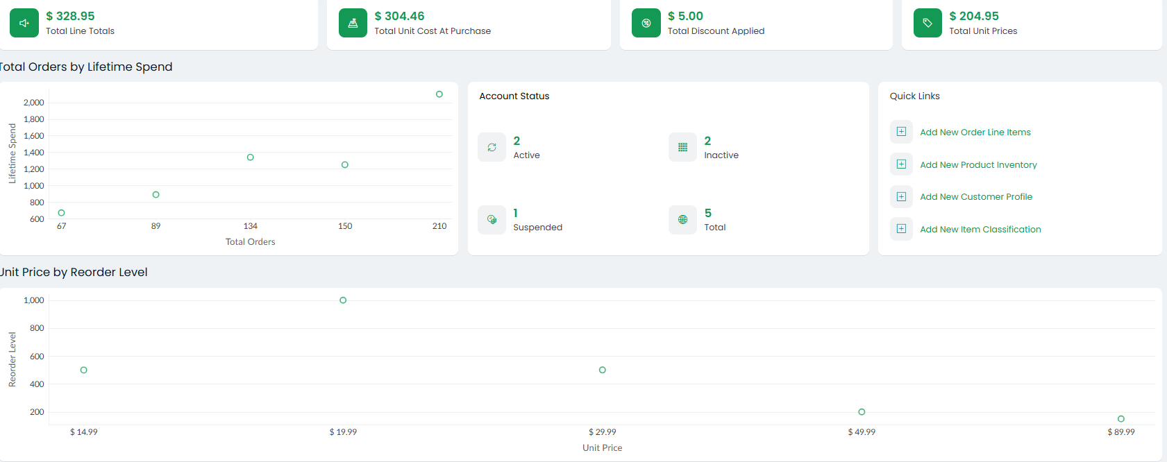
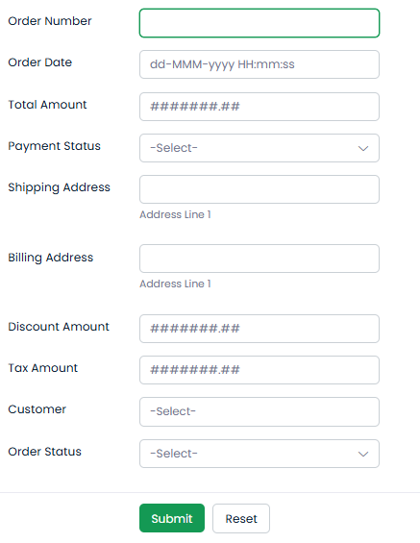
RESULT :
